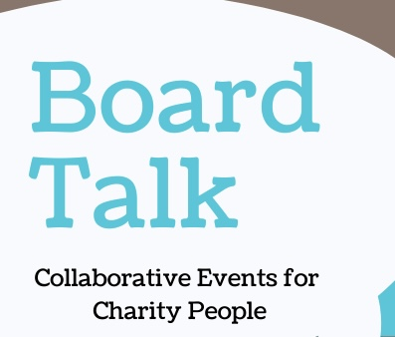
Booking Form
15th October 2025 Cullompton Community Centre
Name
Organisation
Contact Details

Any special food requested
Any access requirements?

Please return to jackie@shinecharityrecruitment.co.uk
by 6th October 2025
Please note that no refunds can be made if you need to cancel after the 6th Oct as we will have already confirmed with the venue and will be charged.

